Grass fed Beef Angus
Honey garlic / Miel et Ail
Sausage Sticks / Bàtonnets de saucissons

Ingredients: Grass fed black angus beef, Water, Sugar (honey), Sea salt, Cultured celery powder, Pepper, Garlic, Starter culture, Olive oil, Natural wood smoke.
Ingredients: Bœuf black angus nourri à l’herbe, Eau, Sucre (miel), Sel de mer, Poudre de céleri de culture, Poivre, Ail, Culture starter, Huile d’olive, Fumée de bois naturel.

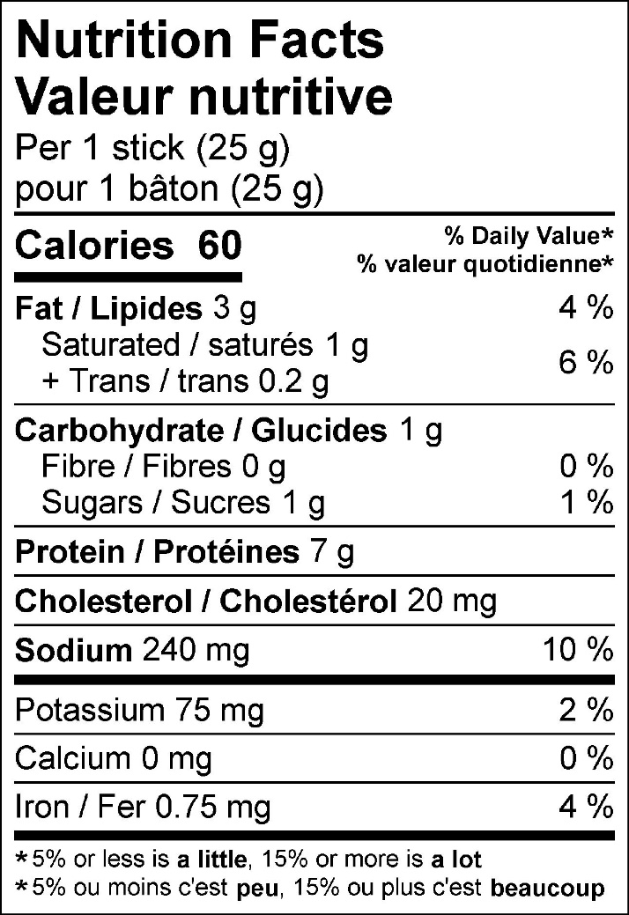

50 g (2-pack) 125 g (5-pack)
